|  |
| --- |
|  |
| 新概念 3 册 |
| Lesson29 |

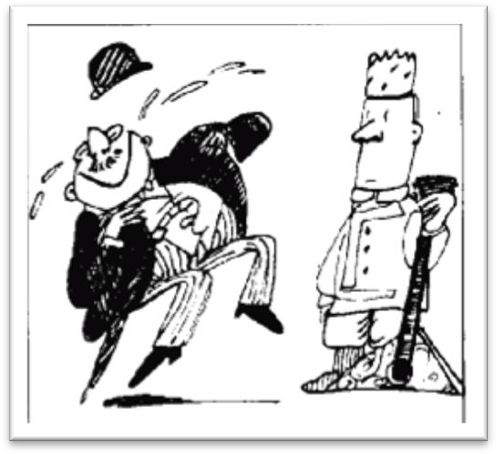Lesson 29 Funny or not

**largely ['lɑ:dʒli]**

**adv. 在很大程度上，主要地**

largely: to a great extent; chiefly

His success was largely due to his hard work. The theory was largely adopted.

mostly: in most cases

We’re mostly out on weekends.

comic ['kɒmɪk]

**adj. 喜剧的；可笑的**

comic → comedy

funny amusing diverting tragic → tragedy

farcical → farce dramatic → drama **universal [ju:nɪ'vɜ:sl] adj. 普遍的**

cosmic cosmos comic comet cosmetics

global international world-wide

English has now become an international language. Therefore, if you have a good command of this language, you hold the key to success.

universally

It is universally known that ...

comedian [kə'mi:diən]

**n. 喜剧演员，丑角**

comedian comedienne comedy tragedian tragedienne tragedy

leading role / part protagonist

leading man hero

leading lady heroine

supporting role extra

distasteful [dɪs'teɪstfl]

**adj. 讨厌的，令人不愉快的**

be distasteful to sb.

It is distasteful to me to say this, but ......

I hate to say this, but ......

disgusting disgust

revolting revolt

repellent repel

repulsive repulse

pester ['pestə(r)]

**v. 纠缠，一再要求**pester sb. for sth. pester sb. with sth.

He pestered me with complaints. He pestered me for money.

harry harass assail

recovery [rɪ'kʌvərɪ]

**v. 恢复原状；康复**

recovery from ...

recovery from illness recovery from defeat

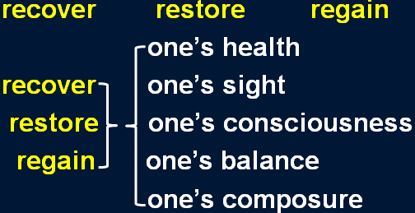

console [kən'səʊl]

**v. 安慰，慰问**console sb. for sth. console sb. with sth.

I consoled him for the loss of money. I consoled him with money.

comfort

comfort a dying man soothe

soothe a crying baby

calm sb. down condole with sb.

The widow’s friends condoled with her at the funeral.

compensate ['kɒmpenseɪt]

**v. 弥补，补偿**

compensate (sb.) for sth.

Nothing can compensate (him) for his loss. more than compensate for ...

His rise in status more than compensates for the loss of money. make up for ...

redeem ...

offset ...

Whether we find a joke funny or not largely depends on *where we have been brought up*.

表示“是否”时不能用 if 的几种情况：

1、主语从句位于句首时

*If she likes the present* is not clear to me. X

It is not clear to me *if / whether she likes the present*. √

*Whether she likes the present* is not clear to me. √ 2、引导表语从句时

The question is *if we have enough money.* X

The question is *whether we have enough money.* √ 3、引导同位语从句时

You have yet to answer my question *if I can count on your help*. X

You have yet to answer my question *whether I can count on your help*. √ 4、作介词宾语时

He was worrying about *if he had hurt her feelings*. X

He was worrying about *whether he had hurt her feelings*. √ 5、引导动词不定式时

I don’t know *if to see my doctor today*. X

I don’t know *whether to see my doctor today*. √ 6、直接跟 or not 时

Please tell me *if or not you agree*. X Please tell me *whether or not you agree*. √ Please tell me *if you agree or not*. √ largely: chiefly / to a great extent

depend on ... rest on ...

rely on...

ride on ... hinge on ... lean on ...

be dependent on ...

be based on ... be built on ...

be founded on ... be decided by ... be dictated by ...

be determined by ...

Whether you find a joke funny or not largely rests / relies / rides / hinges / leans on where we have been brought up.

Whether you find a joke funny or not is largely dependent / based / built / founded on where we have been brought up.

Whether you find a joke funny or not is largely decided / dictated / determined by where we have been brought up.

bring up sb.

He was brought up by his step-mother. raise sb.

foster / adopt sb. adopted son adoptive parents foster-parents

be brought up to do

The sad truth is that most of us have been brought up to eat certain foods and we stick to them all our lives.

We have been brought up to fear insects. the sense of pride

the sense of honor

the sense of accomplishment the sense of responsibility the sense of superiority

the sense of inferiority

be bound up with ...

**be closely connected with ...**

Everyone’s future is bound up with the destiny of the Chinese nation.

bind

be bound to do ...

On our road ahead, we are bound to meet with difficulties. be / feel bound to do ...

I felt bound to tell him the truth. be / feel obliged to do ...

However, as the evidence began to accumulate, experts from the Zoo felt obliged to investigate, for the descriptions given by people who claimed to have seen the puma were extraordinarily similar.

bind sb. to do

The Kyoto Protocol binds each country to reduce the emission of greenhouse gases.

A Frenchman, for instance, might find it *hard* to laugh at a Russian joke. a Frenchman

the French

an Englishman

the English / British

No matter where you live, you would find it *difficult* not to laugh at, say, Charlie Chaplin's early films.

In the same way, a Russian might fail to see anything *amusing* in a joke which would make an Englishman laugh to tears.

laugh to tears

be bored to tears / death laugh one’s head off

in the same way likewise similarly

**by the same token**

... which would make an Englishman laugh his head off. clap one’s hands off

cry one’s eyes out

contrast 对比

A mother takes twenty years to make a man of her boy, and another woman makes a fool of him in twenty minutes.

Men always want to be a woman’s first love; women have a more subtle instinct: what they like is to be a man’s last romance.

universal: international, global, world-wide appeal: attraction, charm, fascination

an international attraction a global charm

a world-wide fascination appeal to sb.

The idea never appealed to me very much, ... attract / charm / fascinate sb.

Cats never fail to fascinate human beings. appealing

attractive charming fascinating

No matter where you live, you would find it *difficult* not to laugh at, *say*, Charlie Chaplin's early films.

Wherever you live, ......

Whoever wants to sign up for the course is welcome. √

No matter who wants to sign up for the course is welcome. X

No matter who wants to sign up for the course, he is welcome.√

Whatever project he works on is always successful.

No matter what project he works on, it is always successful. (let’s) say

Why don’t we have a break until, (let’s) say, 10:45?

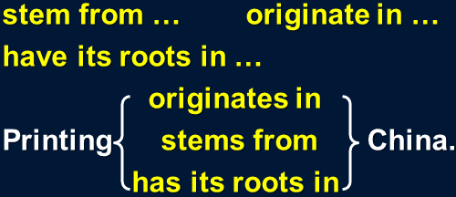Say / Let's say (that) the journey takes three hours, you'll arrive at 2 o'clock.

arise from ...

The argument arose from misunderstanding. come / hail from ...

I come / hail from China. come into fashion

Miniskirts have come into fashion. be in fashion

be out of fashion

fashionable clothes / ideas / hairstyles … come into use

Computers first came into use in the early 1950s. come into effect

The new seat-belt regulations came into effect last week. come into blossom

The trees are late coming into blossom this year. come into being

Up to now, historians have assumed that calendars came into being with the advent of agriculture, …

Comedians build their jokes on tragic situations ... Comedians found their jokes on tragic situations ...

Many people find this sort of joke unpleasant / disgusting / repellent / revolting / repulsive. Many people dislike / hate / despise / abhor / detest / loathe / abominate this sort of joke. This sort of joke repels / revolts / repulses / disgusts / sickens many people.

the following example the ensuing example

the under-mentioned example the example below

the previous example the preceding example

the above-mentioned example

the example above enable sb. to do

They devise hundreds of competitions which will enable us to win huge sums of money. allow / permit sb. to do

make it possible for sb. to do

Radio and television have made it possible for advertisers to capture the attention of millions of people in this way.

... will allow / permit you to judge for yourself.

... will make it possible for you to judge for yourself. do sth for oneself

So great is our passion for doing things for ourselves, that we are becoming increasingly less dependent on specialized labor.

A man who had broken his right leg was taken to hospital *a few weeks before Christmas*. A man whose right leg had been broken ......

take sb. to hospital send sb. to hospital go to hospital

be in hospital be hospitalized leave hospital

the outpatient department (OPD) the inpatient department (IPD) casualty emergency room (ER)

From the moment he arrived there, he kept on pestering his doctor *to tell him when he would be able to go home*.



Since the moment he arrived there, he had kept on pestering ...

keep (on) doing

Why do you keep (on) making the same mistakes? How can I explain if you keep (on) interrupting me?

In the process, he enjoyed himself thoroughly and kept telling everybody how much he hated hospitals.

dread + n. / doing

She dreads getting old. dread to do

I dread to think what will happen if I fail.

She dreads to get old. X do / try one’s best to do

do / try one’s utmost to do

do everything / all one can to do give one’s all to do

spare no effort to do go all out to do

go to great lengths to do

The man went to great lengths to prove that the diamonds were real. on Christmas Day

on Easter Day

at Christmas at Easter The only regular visitors to the

monastery in winter are parties of skiers who go there at Christmas and Easter.

..., the man’s right leg was still in plaster.

He spent a miserable day in bed thinking of all the fun he was missing.

The following day, *however*, the doctor consoled him *by telling him that his chances of being able to leave hospital in time for new year celebrations were good*.

The following day, however, the doctor consoled him by telling him that his chances of being able to leave hospital in time for new year celebrations were good.

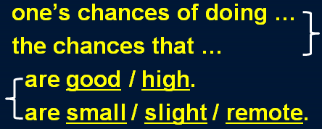As she is not rich, the chances that she will ever be able to afford such purchases are remote; but she is never sufficiently strong-minded to be able to stop the practice.

造句：他赢得这次比赛的可能性很小。

His chances of winning the game are remote.

The chances that he will win the game are remote. take heart = be encouraged

lose heart

lose one’s heart to ... sure enough

as expected

... than what was good for him.

It seems that man was making a real effort to understand the seasons 20,000 years earlier than has been supposed.

The project requires more labor than because it is extremely difficult.

has been put in

have been put in

being put in

to be put in

We often advise him not to drink more wine is good for his health.

as

than

that

but

The experiment requires more money than .

have been put in

being put in

has been put in

to be put in

The indoor swimming pool seems to be a great deal more luxurious than .

is necessary

being necessary

to be necessary

it is necessary

In the process, he enjoyed himself thoroughly and kept telling everybody *how much he hated hospitals*.

..., he had a good / great time ...

... kept telling everybody to what extent he hated hospitals.

To what extent do you love her?

I’ll die for her.

He was still mumbling something about hospitals *at the end of the party* when he slipped on a piece of ice and broke his left leg.

主句 (进行时 / be about to do) + when ... “when”应译为“这时”或“突然”

He was still mumbling something about hospitals at the end of the party when he slipped on a piece of ice and broke his left leg.

The idea never appealed to me very much, but one day, after a heavy shower, I happened to be walking in my garden when I noticed a huge number of snails taking a stroll on some of my prize plants.

The Karen had been sailing in a convoy to Russia when she was torpedoed by an enemy submarine.

The morning passed rapidly and Frank was about to leave when he noticed a large packing case lying on the floor.

slip on a piece of ice trip over a stone

a slip of the pen

a slip of the tongue